
Department of Computer and Communication Engineering

LAB REPORT
Experiment No : 06
Experiment Name : Mini Game Development 01

Course Title : Computer Animation and Game Development Sessional
Course Code : CCE – 3606

Submitted By
Name : Kazi Sultana Sunehra
ID No : E231413
Semester : 6th
Section : 6AF

Date of Experiment: 24. 11. 2025
Remark
Date of Submission: 01. 12. 2025

Submitted To
Md. Warid Bin Azad
Adjunct Faculty, Dept. of CCE, IIUC


Experiment No: 06

Experiment Name: Mini Game Development 01

Name of the Game: Match the Circle!

Game Description:
This is an interactive game built around timing and control. The player starts with a circle at the top of the screen and must grow it to an appropriate radius before releasing it. The first key press begins increasing the radius, and the next key press stops the growth and makes the circle drop vertically. During the fall, the circle has to pass through three horizontally moving obstacles that bounce between the screen boundaries. If the player circle touches any of them, the attempt is cancelled and the initial position is restored. The goal is to reach the target circle at the bottom with the correct radius. When the size and position match, the target highlights the success. Otherwise, the player can try again.

Working Procedure:
- BGI Graphics Functions for Drawing:
  - The program uses the BGI graphics library to draw all visual elements, including the player circle, target circle, and obstacles.
  - circle(x, y, r): draws a circle at the given coordinates with the specified radius.
  - setcolor() and setfillstyle(): define the outline and fill style of circles.
  - floodfill(): fills the drawn circle with the selected color.
  - cleardevice(): clears the screen at the start of each frame, allowing smooth animation.

- Obstacle Movement:
- Obstacles move horizontally by updating their x-coordinates (o1x, o2x, o3x) every frame.
- Their speed is controlled using o1dx, o2dx, o3dx.
- When an obstacle reaches the screen boundary (x < 0 or x > getmaxx()), its direction is reversed by negating the velocity variable (dx = -dx).
- getmaxx() is used to determine the maximum horizontal coordinate of the screen.

- Player Control:
- User input is read using kbhit() (check key press) and getch() (capture key).
- Pressing a key the first time sets start = true, causing the player circle’s radius (nr) to increase every frame.
- Pressing again switches to moving = true, which stops the growth and moves the circle downward by increasing its y-coordinate.
- Collision Detection:
- Collisions between the player circle and obstacles are detected using the Euclidean distance formula:
$$d= \sqrt{{(x_{1}- x_{2})}^{2}+ {(y_{1}- y_{2})}^{2}}$$

- A collision is considered true if:
$$d ≤ {r_{1}+ r_{2}}^{}$$
- In the code, this is evaluated through three boolean checks: hit1, hit2, and hit3.
- If any hit variable becomes true, the player circle resets to its initial position and radius, and both start and moving are cleared.

- Target Circle Matching:
- The program checks if the player circle’s radius matches the target circle’s radius when it reaches the target’s vertical position (ny == my).
- If the radius matches, the target circle is drawn in green; otherwise, it appears red.

Algorithm:
- Start the program.
- Initialize graphics window and all variables (player, target, obstacles).
- Clear the screen (cleardevice()).
- Draw player, target, and obstacles using circle() and floodfill().
- Update obstacle positions; reverse direction if boundary is reached.
- Check user input:
  - If start = true, increase player radius.
  - If moving = true, move player downward.
- Check collisions using the distance formula; evaluate hit1, hit2, and hit3.
- If a collision is detected, reset the player’s position, radius, and booleans.
- If the player reaches the target y-coordinate, check whether the radius matches the target’s radius.
- Delay and repeat loop.
- Close graphics window.
- End the program.
Source Code:
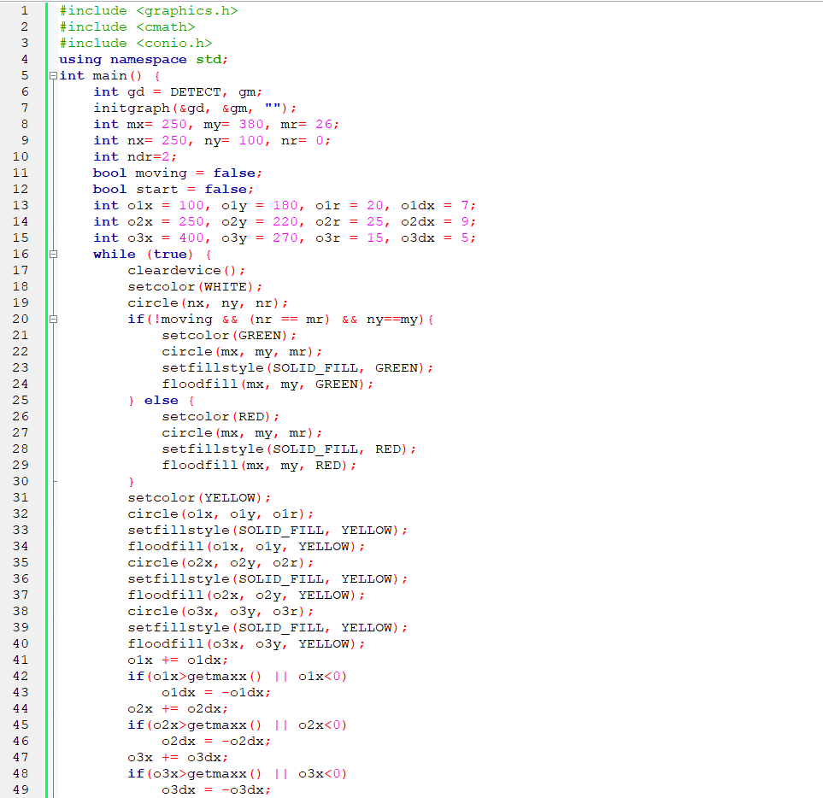
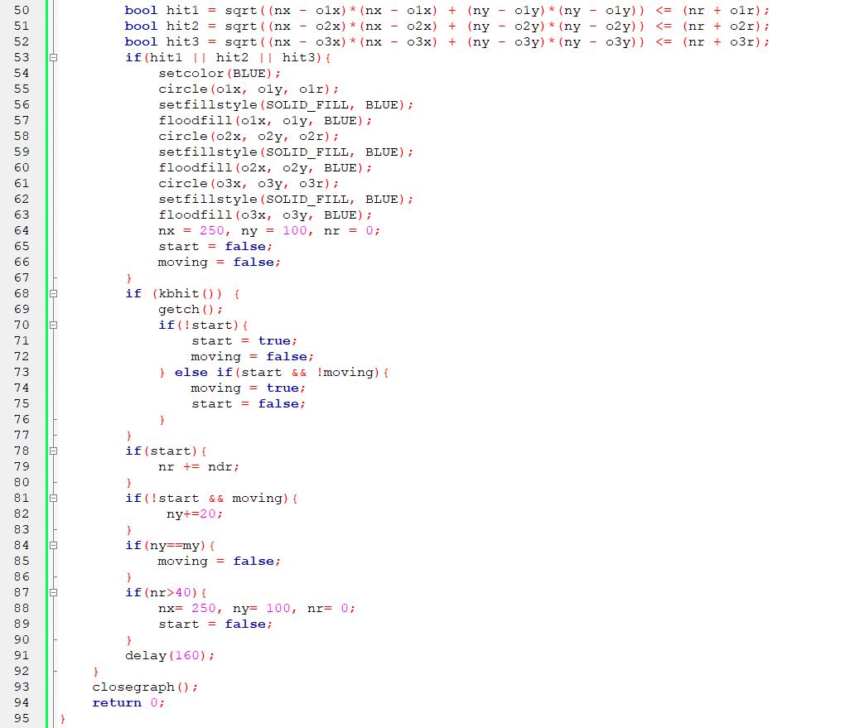
Figure – 1: Source Code
Output:
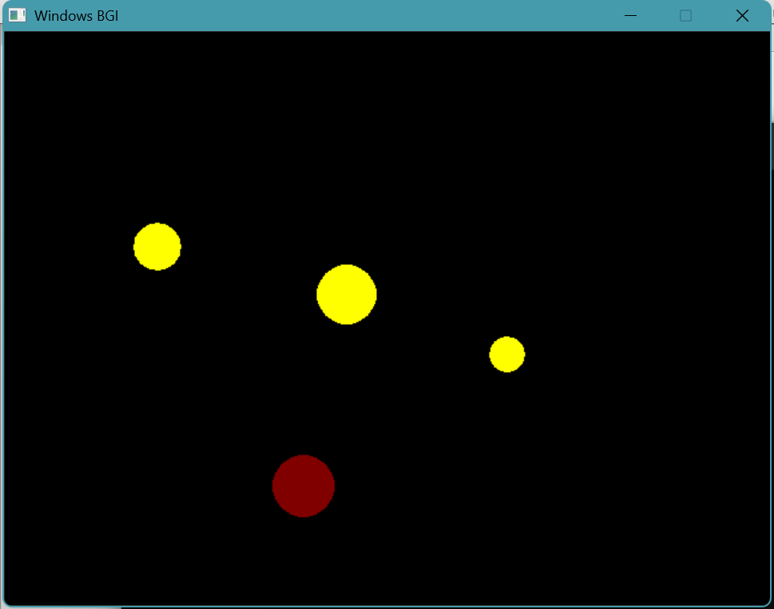
Figure – 2: Initial Screen

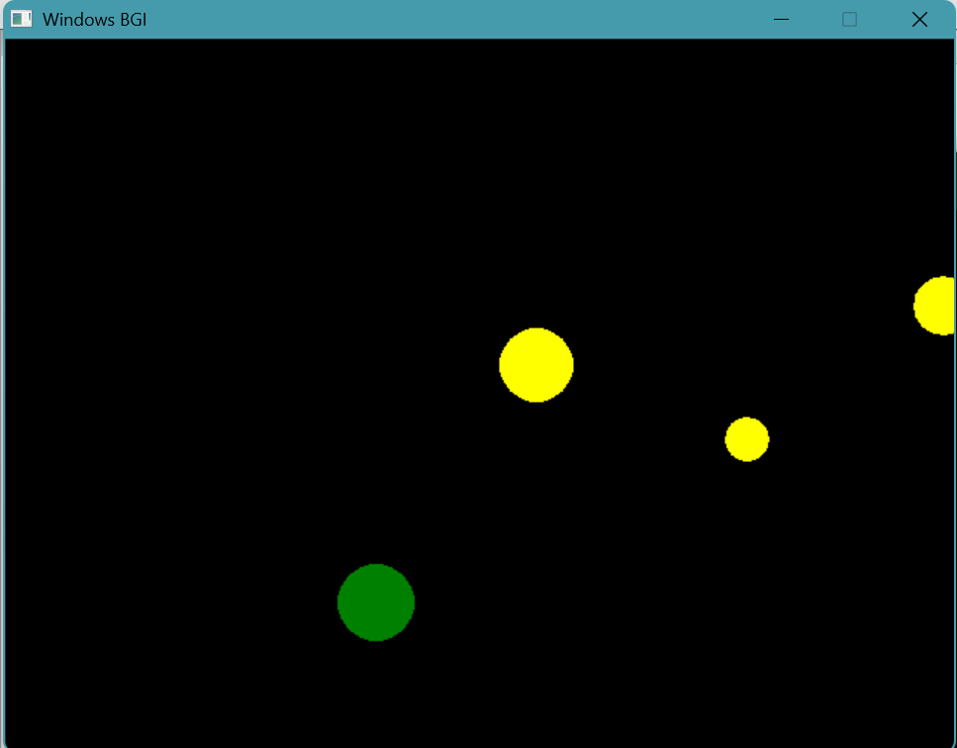
Figure – 3: Target Hit

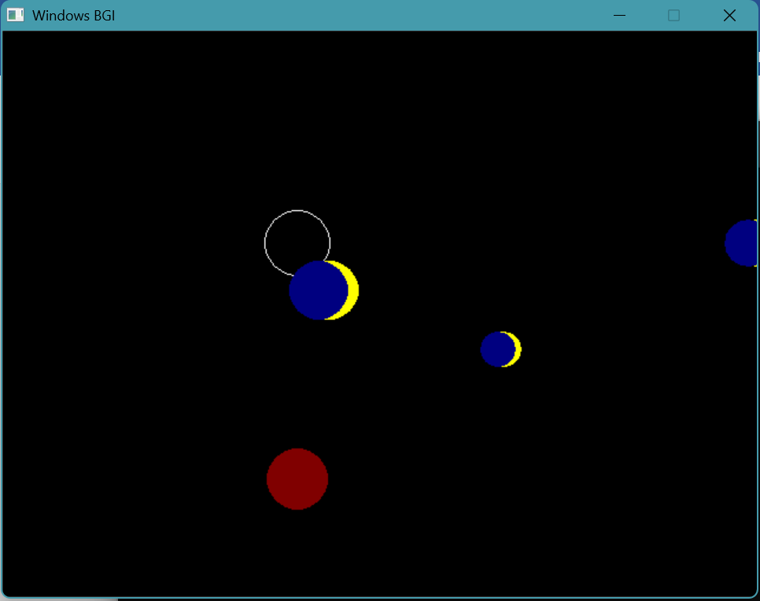
Figure – 4: Collision

